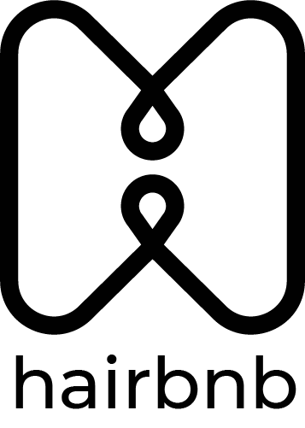

User Manual

Login Portal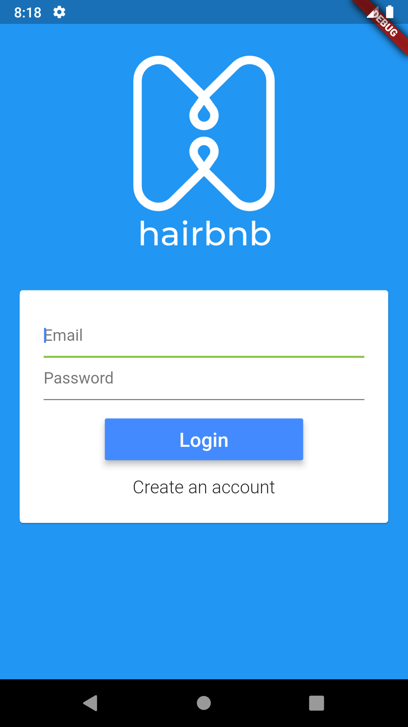

The Login portal allows a previous user to login using their email and password they signed up with.

Steps to Login

1. Enter the email you used to sign up with into the email text input.
2. Enter the password you associated with this account into the password text input.
3. Tap the blue login button.

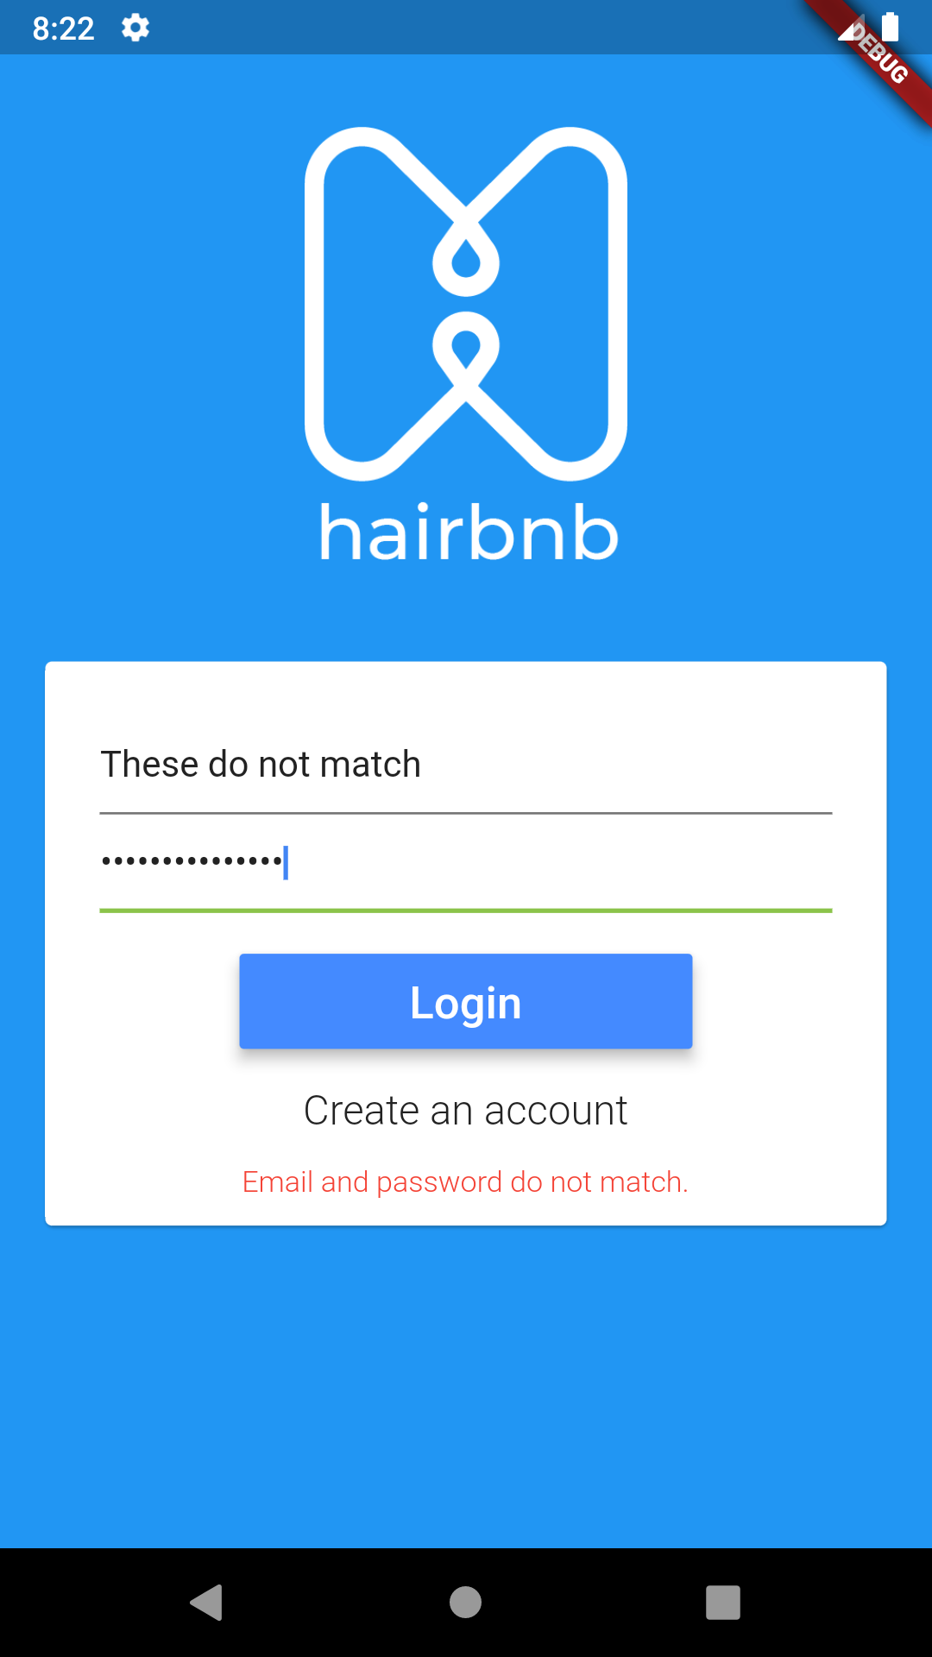

If your email and or password do not match one currently stored in the database, you will be presented with a message saying the email and password do not match.

On successful login, you will be taken to a new page.

Sign Up Portal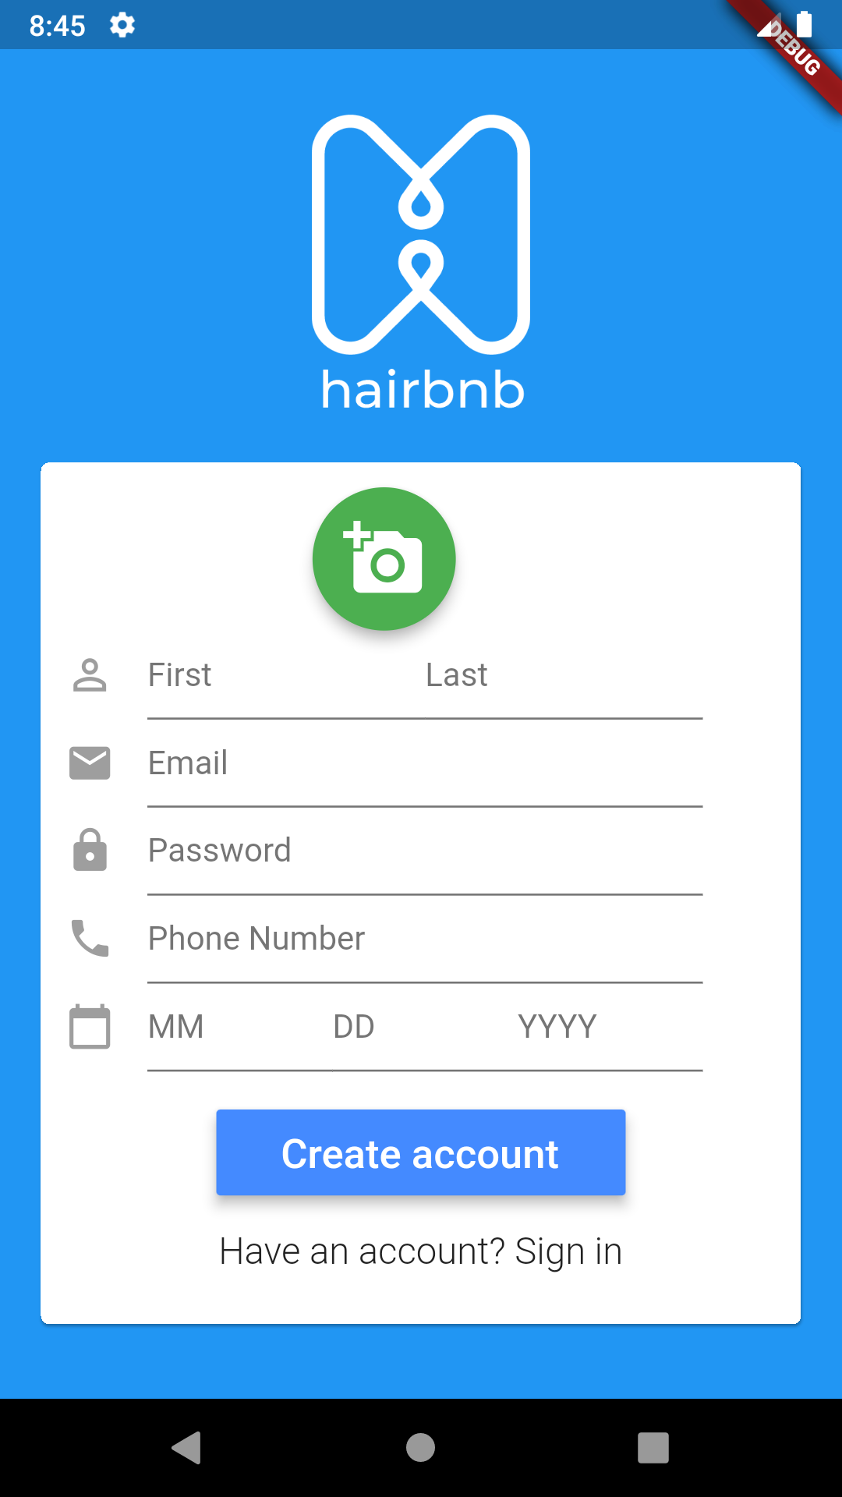

The signup portal allows a new user to create an account. To create an account, one needs to provide a profile picture, email, password, first and last name, phone number and birthday.

Steps to Sign Up

1. Select a profile photo by tapping on the camera icon. This will prompt the user with two new buttons, one to select the picture from the device’s gallery and one to take a picture with the camera.
   1. If you tap on the from gallery button, your device’s gallery will open and you can select an image from there.
   2. If you tap on the from camera button, your device’s camera will open and you can take a picture from there.

Once you select an image from your gallery or take one from the camera, you will be prompted to crop your image into a square. After cropping, tap the check mark in the top right, it will bring you back to the form.

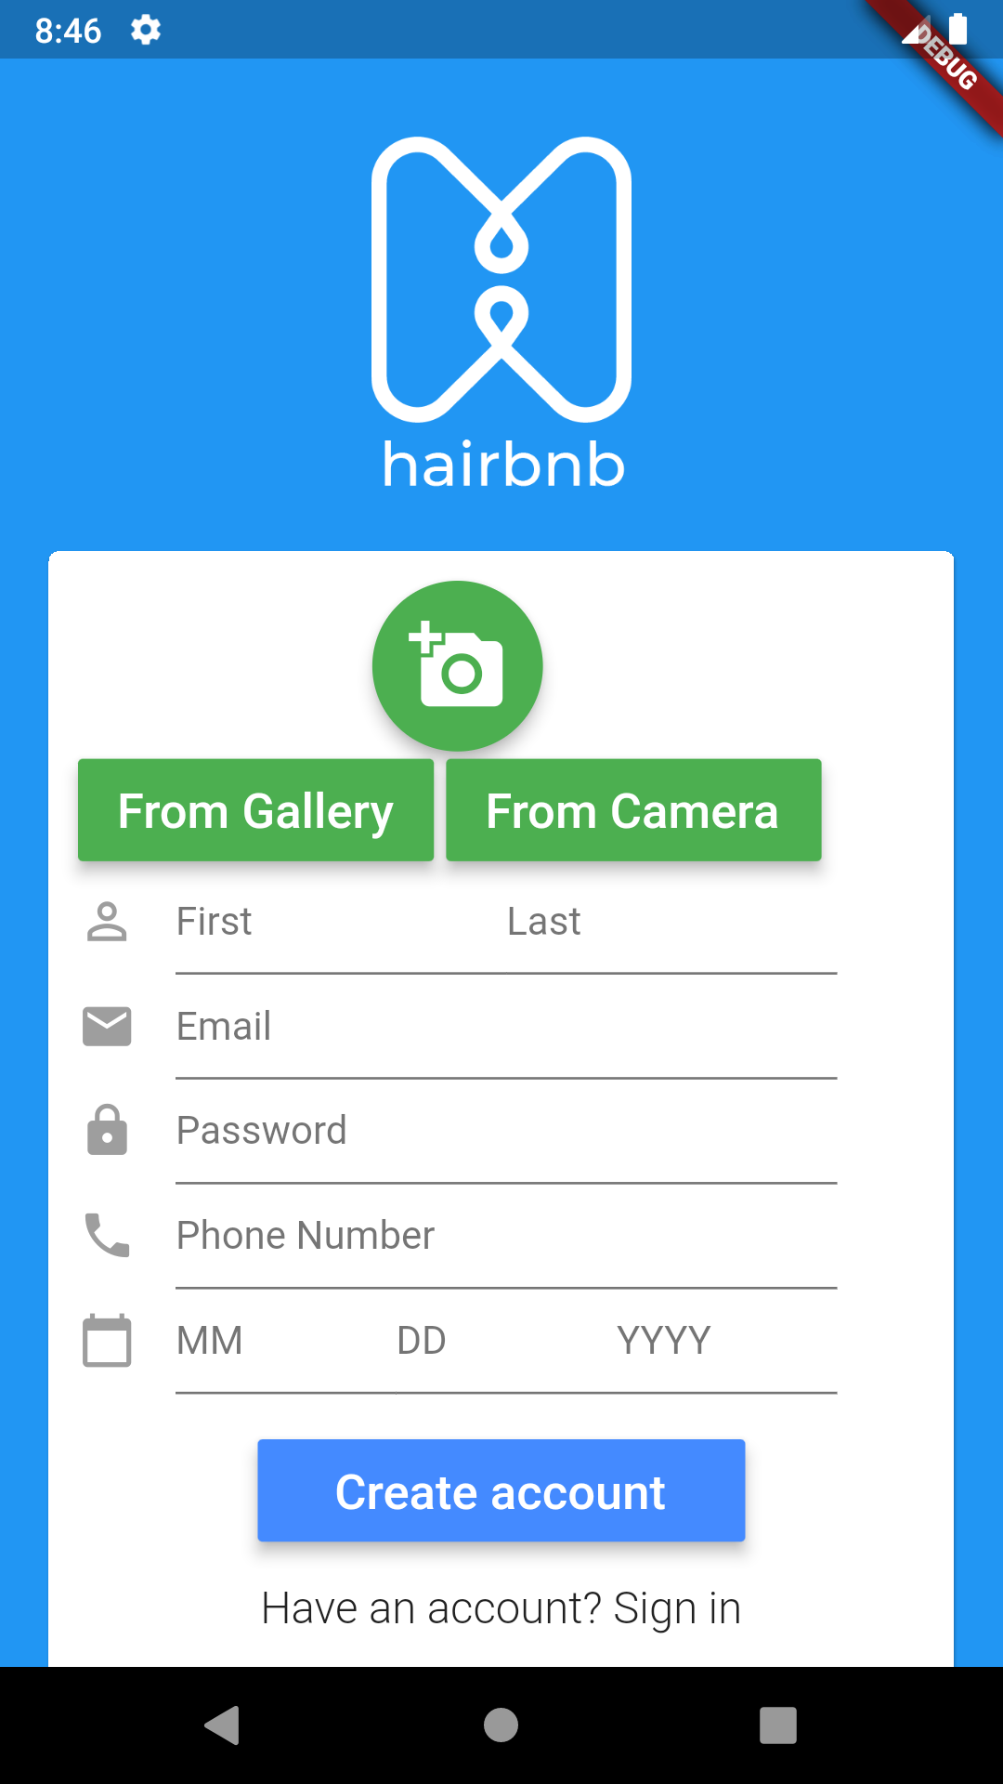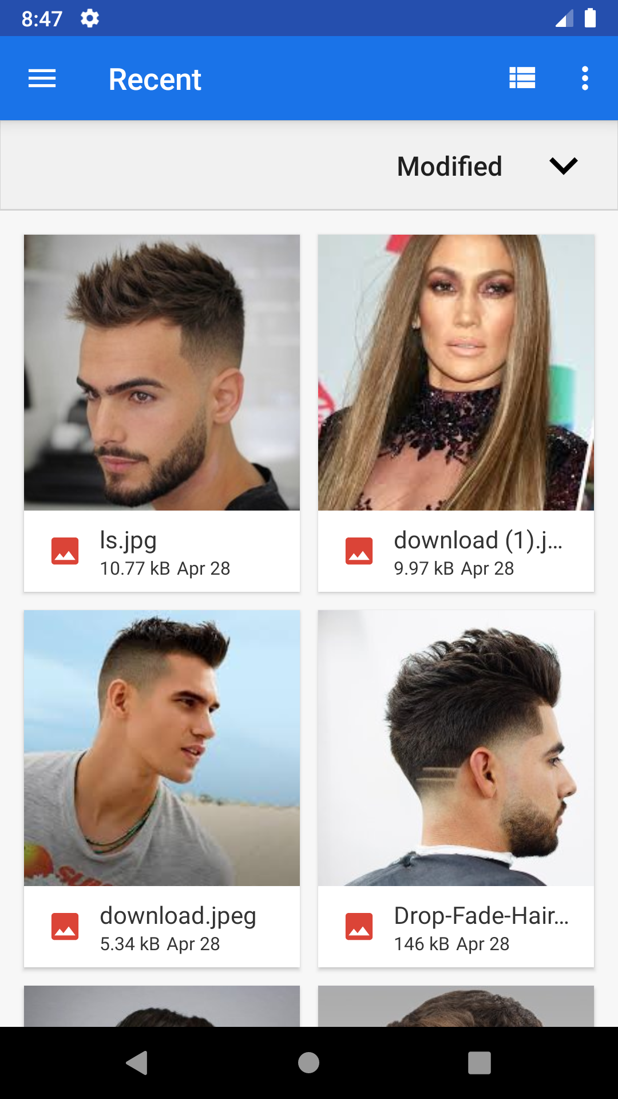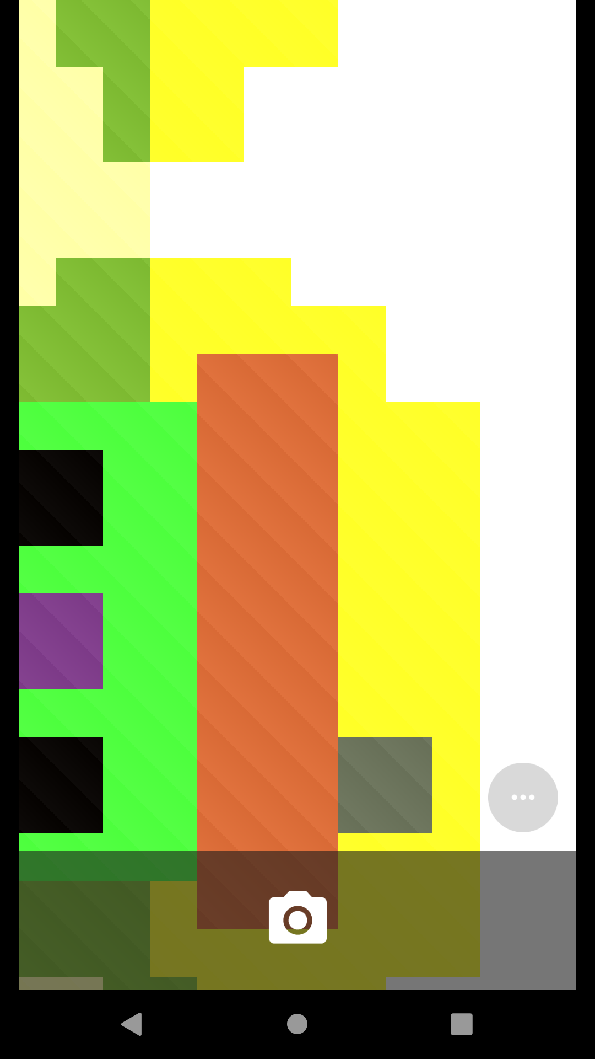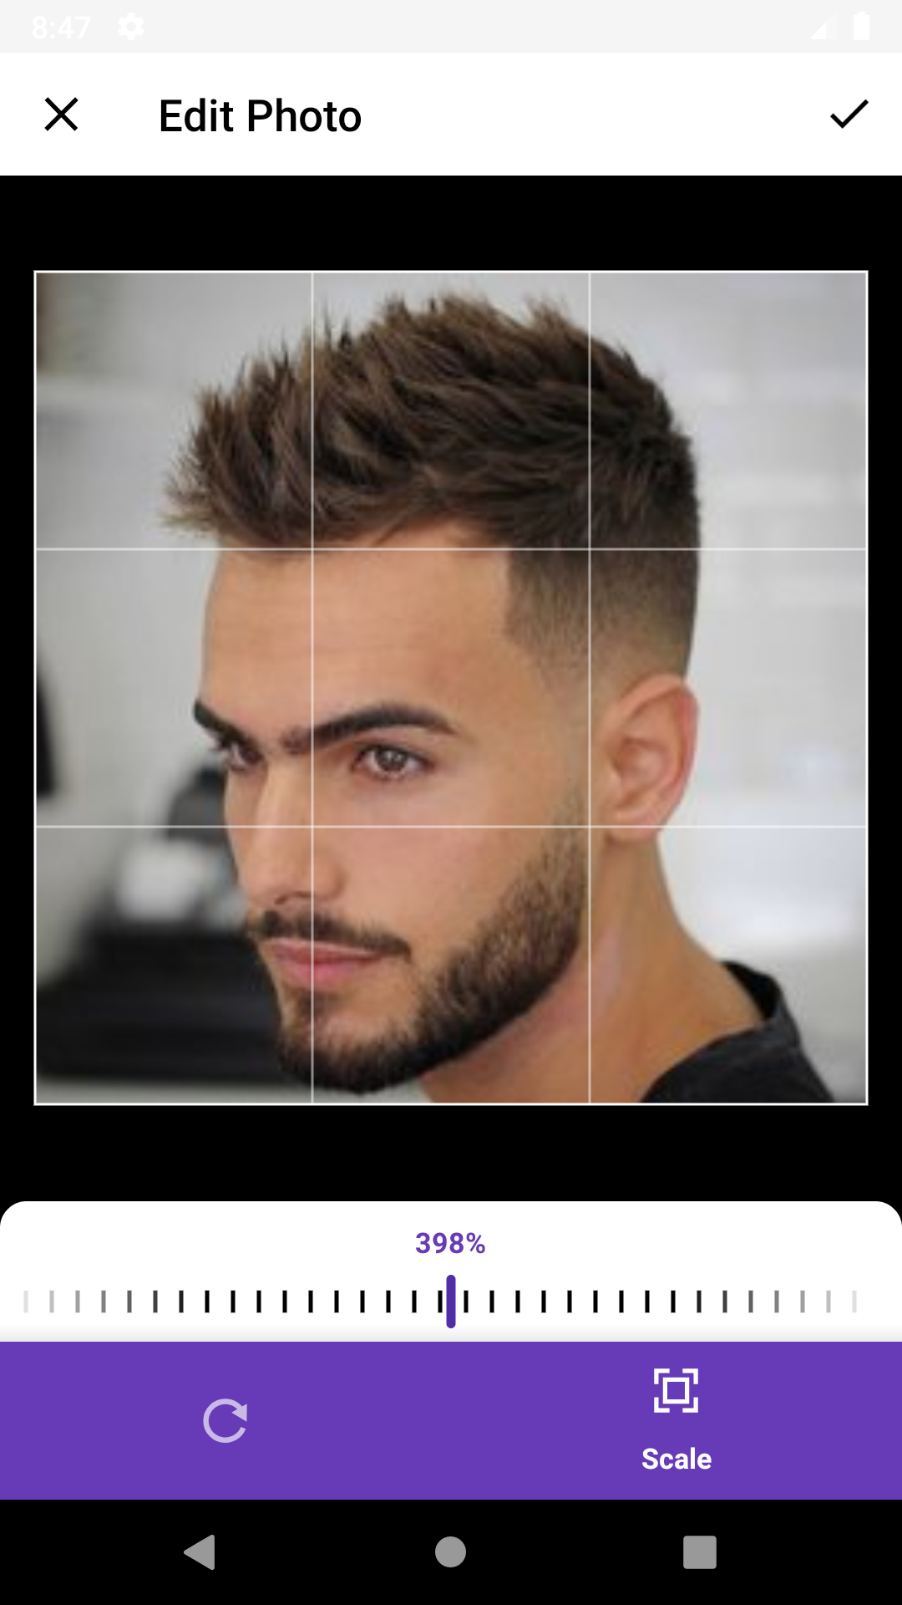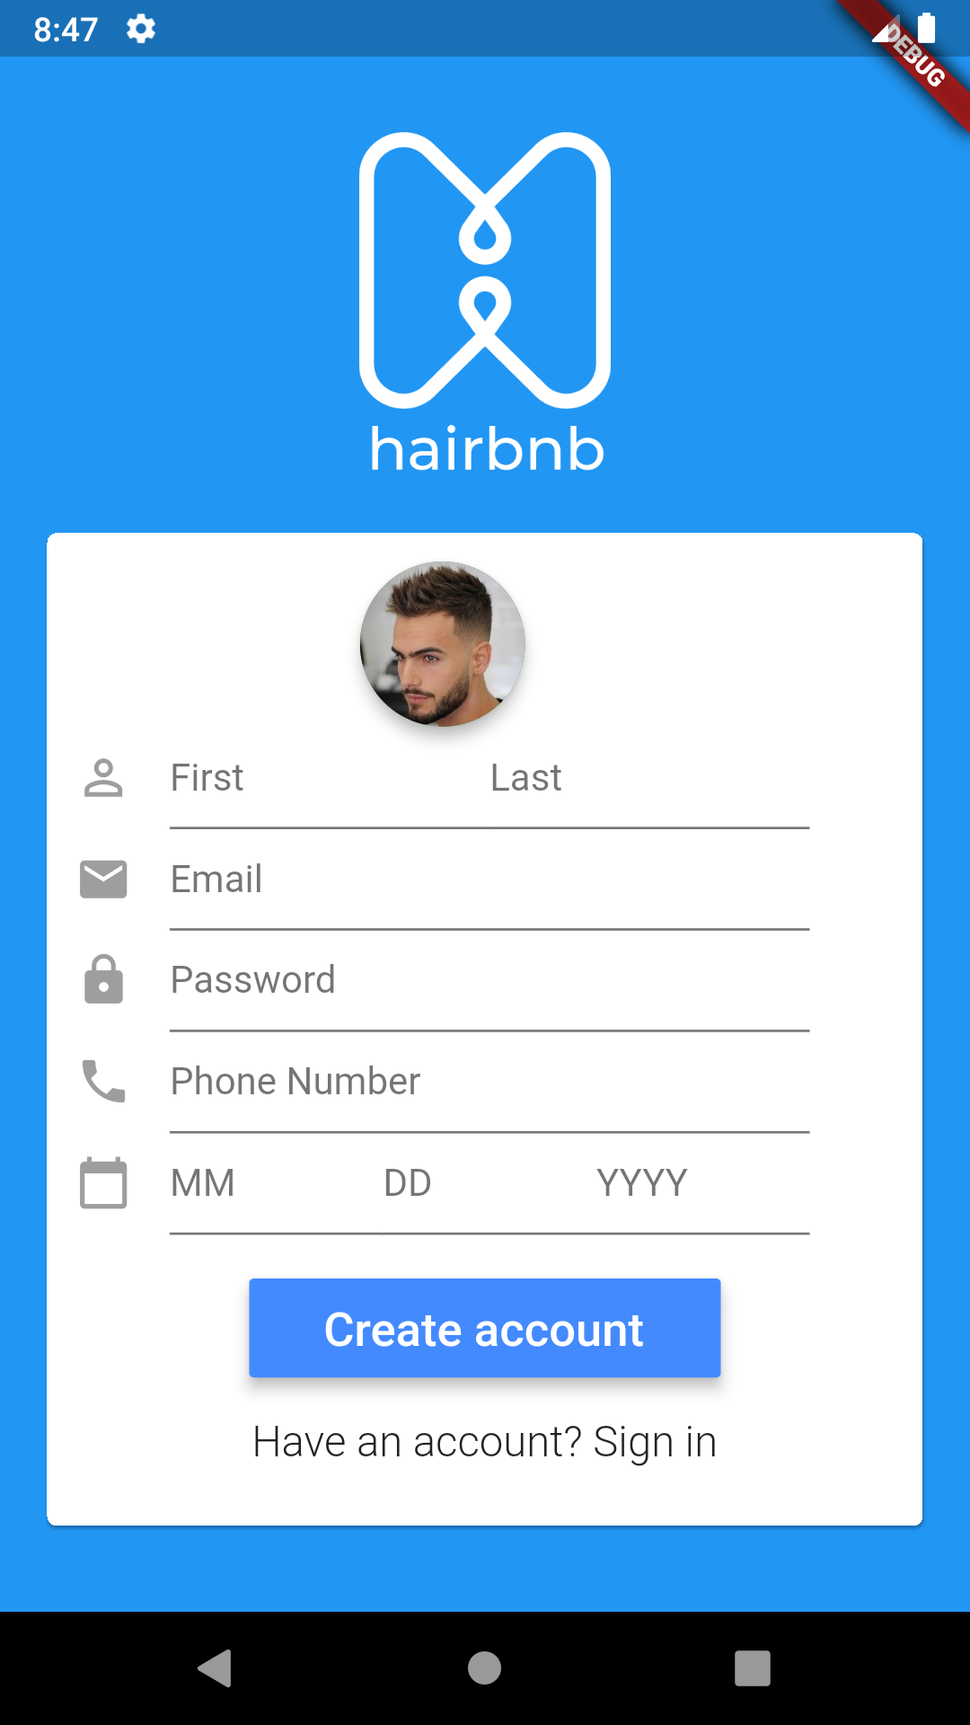

2. Enter your first and last name into the text input fields.

3. Enter a valid email into the email input fields.

4. Enter a valid password into the password input field.

Your password must meet the following conditions:

* Must be between 4 and 8 characters.
* Must contain at least one lowercase letter.
* Must contain at least one uppercase letter.
* Must contain at least one number.

5. Enter a valid phone number into the phone input field.

Your phone number must be 10 digits and must only contain numbers.

6. Enter a valid birthday into the birthday input fields.

Your birthday must be before today’s date and must be in the form of MM/DD/YYYY.

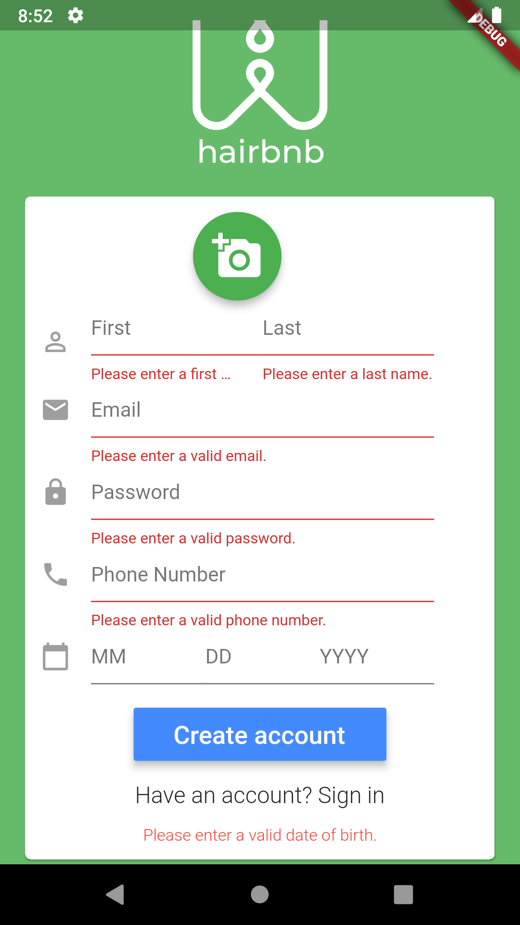

All of these inputs are mandatory. If any of the inputs are invalid you will be prompted with an error message saying what the problem is.

On a successful signup, you will be taken to a new page.

Owner Portal

The owner portal allows the owner of the barbershop to view basic information about their shop, current appointments and all of their customers.

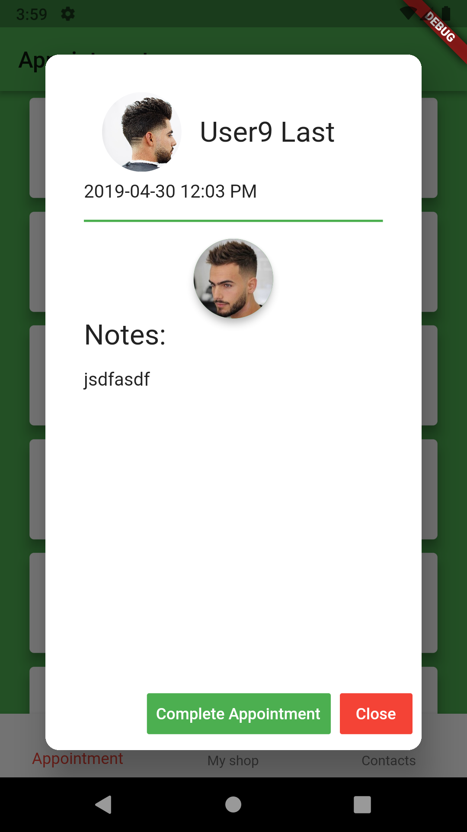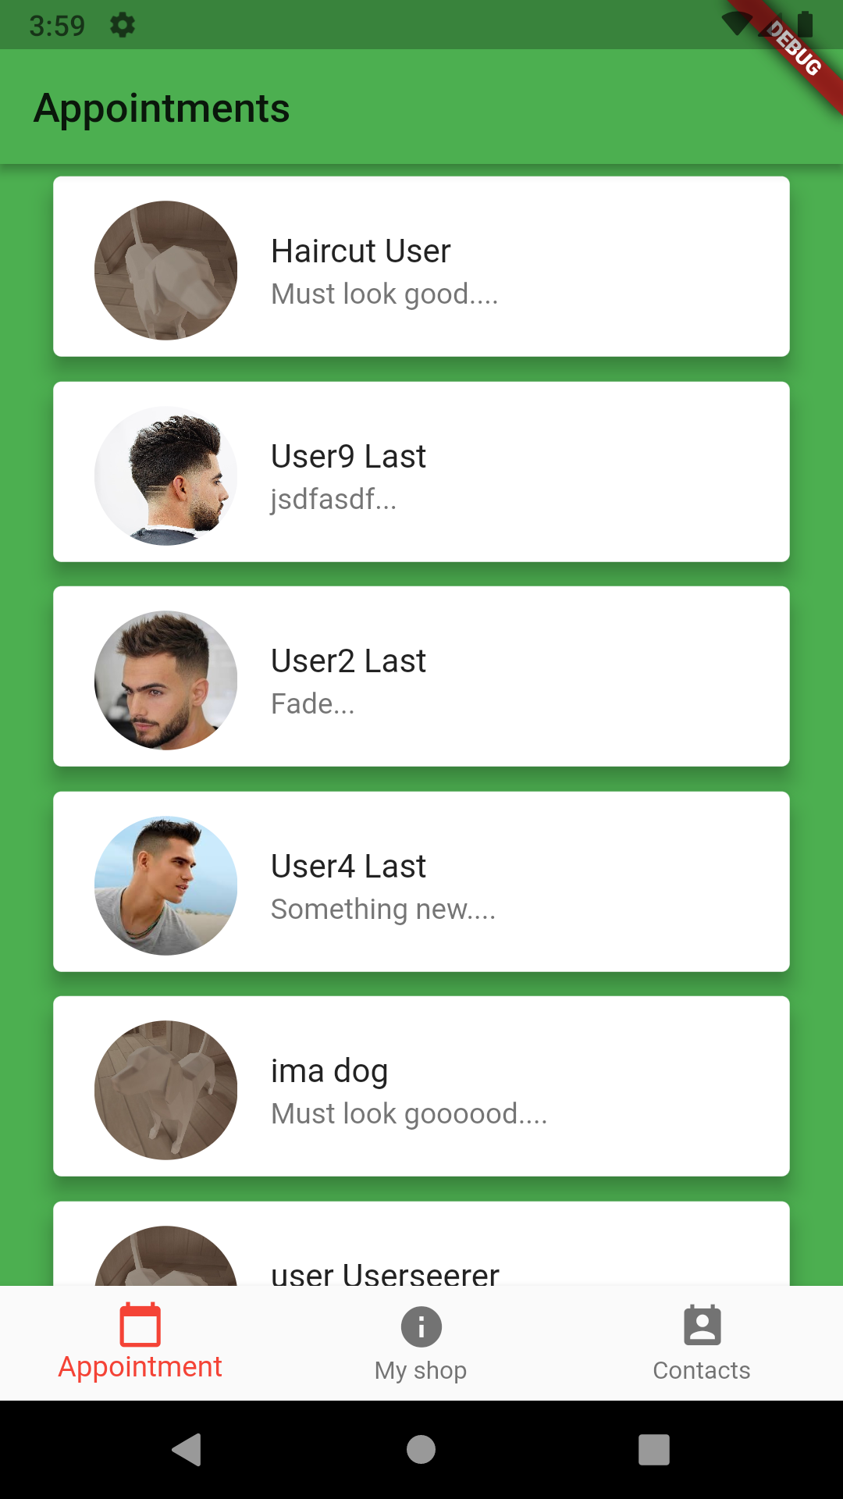

To login to the owner portal, from the login portal enter “admin” as the email and tap the login button.

**Appointment Page**

On the first load, the owner portal defaults to the appointment page which is where the owner can view the current appointments ordered by time.

You can view more details about the appointment by tapping on it. From this dialog, you can tap the complete appointment button to remove the appointment from the appointment list or close the dialog.

**My Shop Page**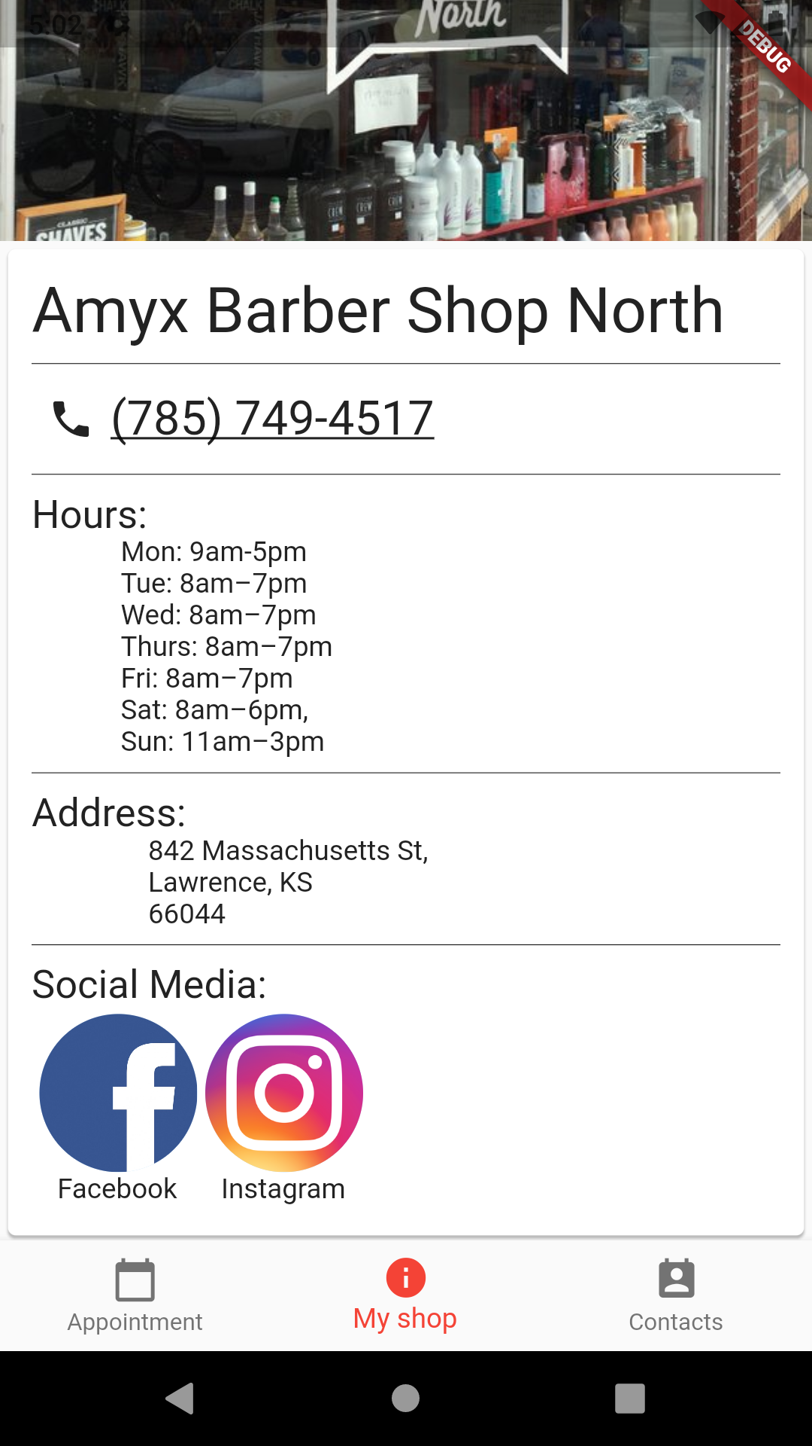

You can navigate to my shop page by clicking on the tab at the bottom labeled my shop. This page is to show the owner information about their shop. It includes the name of the shop, the phone number, hours of operation, address, and some links to the shop’s social media links.

When you click on the phone number, it will open the phone app on your device, so you can call the shop. When you click on the links to social media, it will open the corresponding social media link.

**Contacts Page**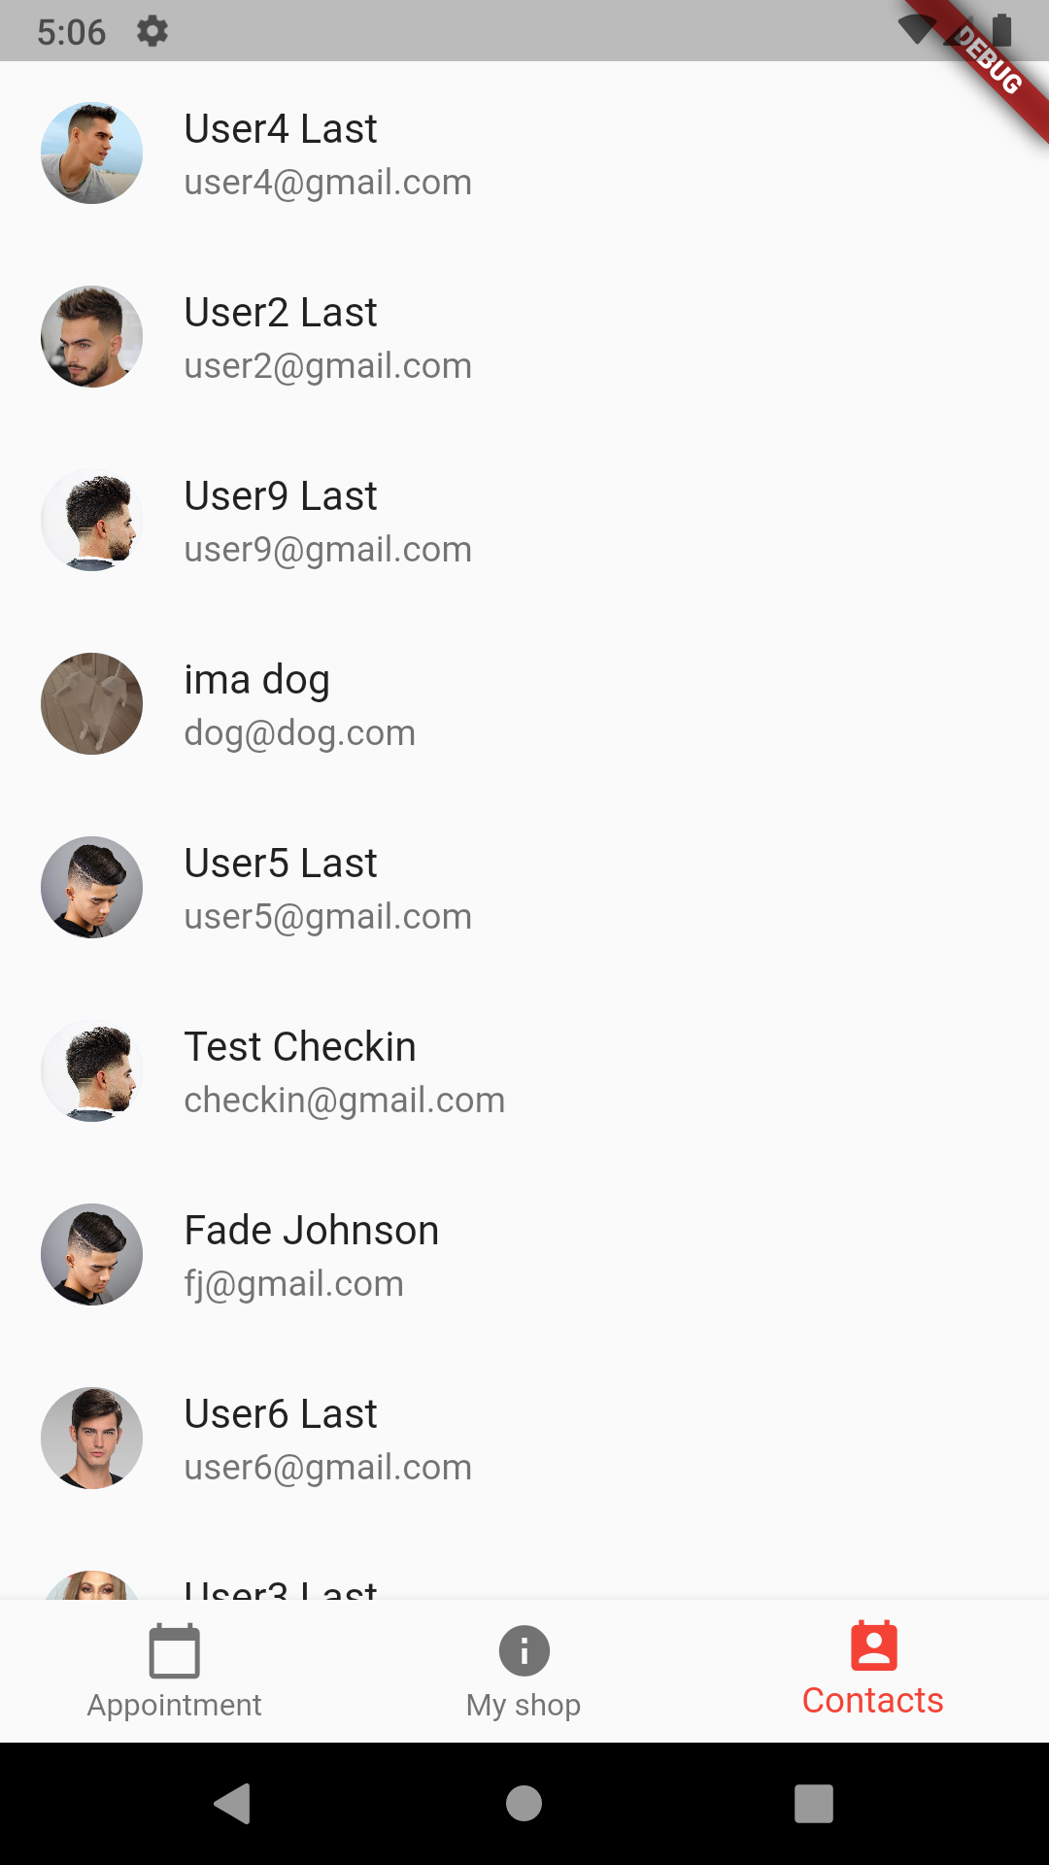

You can navigate to my shop page by clicking on the tab at the bottom labeled Contacts. This page shows a list of all of the customers with accounts.

To see more information about a customer you can tap on their name and a dialog will show up with more information about the customer.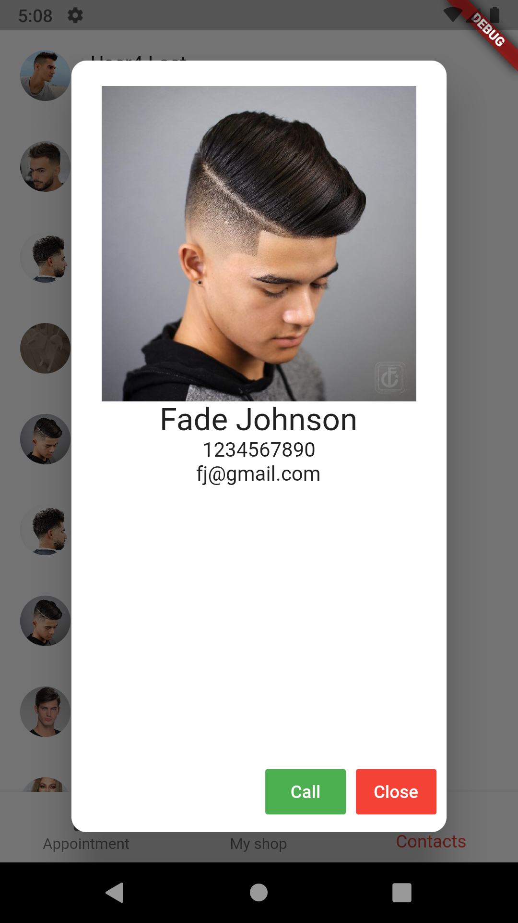

This dialog shows a large picture of the customer’s profile photo, their full name, phone number, and email. From the dialog, you have the option to call the customer, which will open the phone app on your device, or close the dialog.

Customer Portal

The customer portal allows a customer of the barbershop to view basic information about the barber shop, create an appointment, and edit their profile information.

To login to the customer portal, from the login portal enter a valid email and password combination if you already have an account. Otherwise, you will have to sign up using the signup portal. Once you sign up you will be taken to the customer portal.

**Check-in Page**

Once in the customer portal, you will be presented with the check-in page. 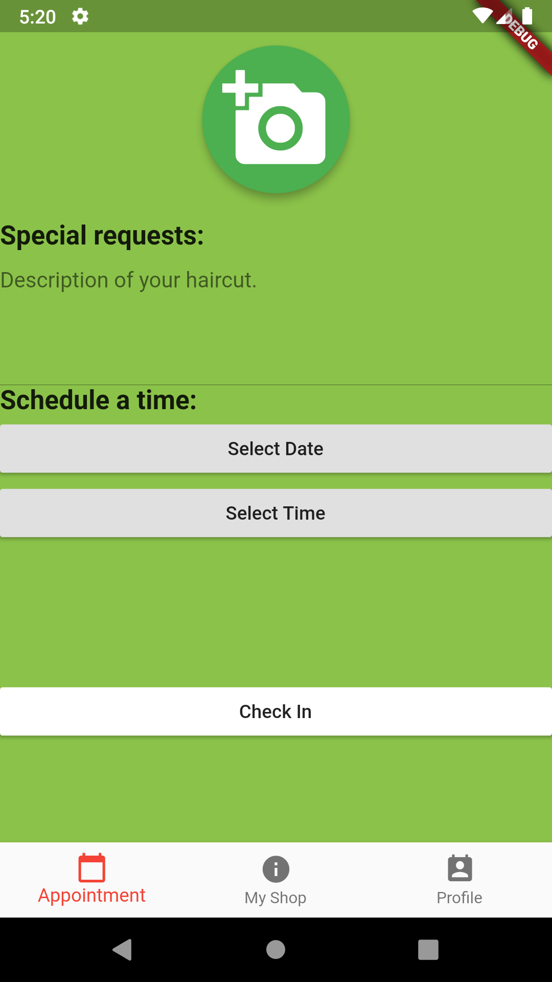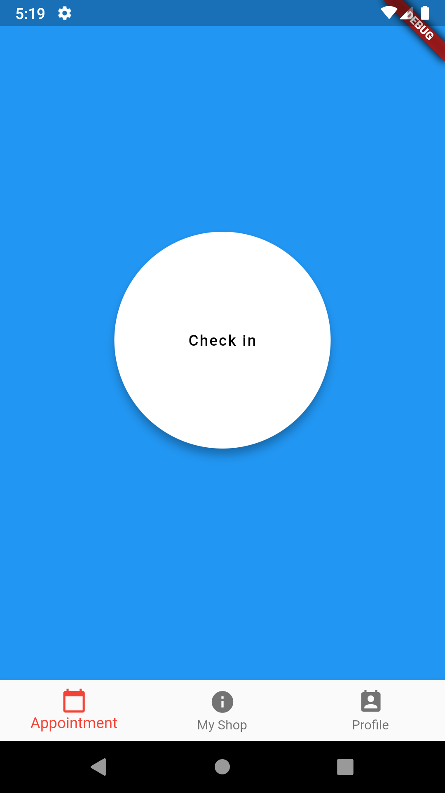

This page consists of a big button that when clicked will show a form to make an appointment.

This form requires an image of the haircut you want, a description of the haircut, and a date and time for the appointment.

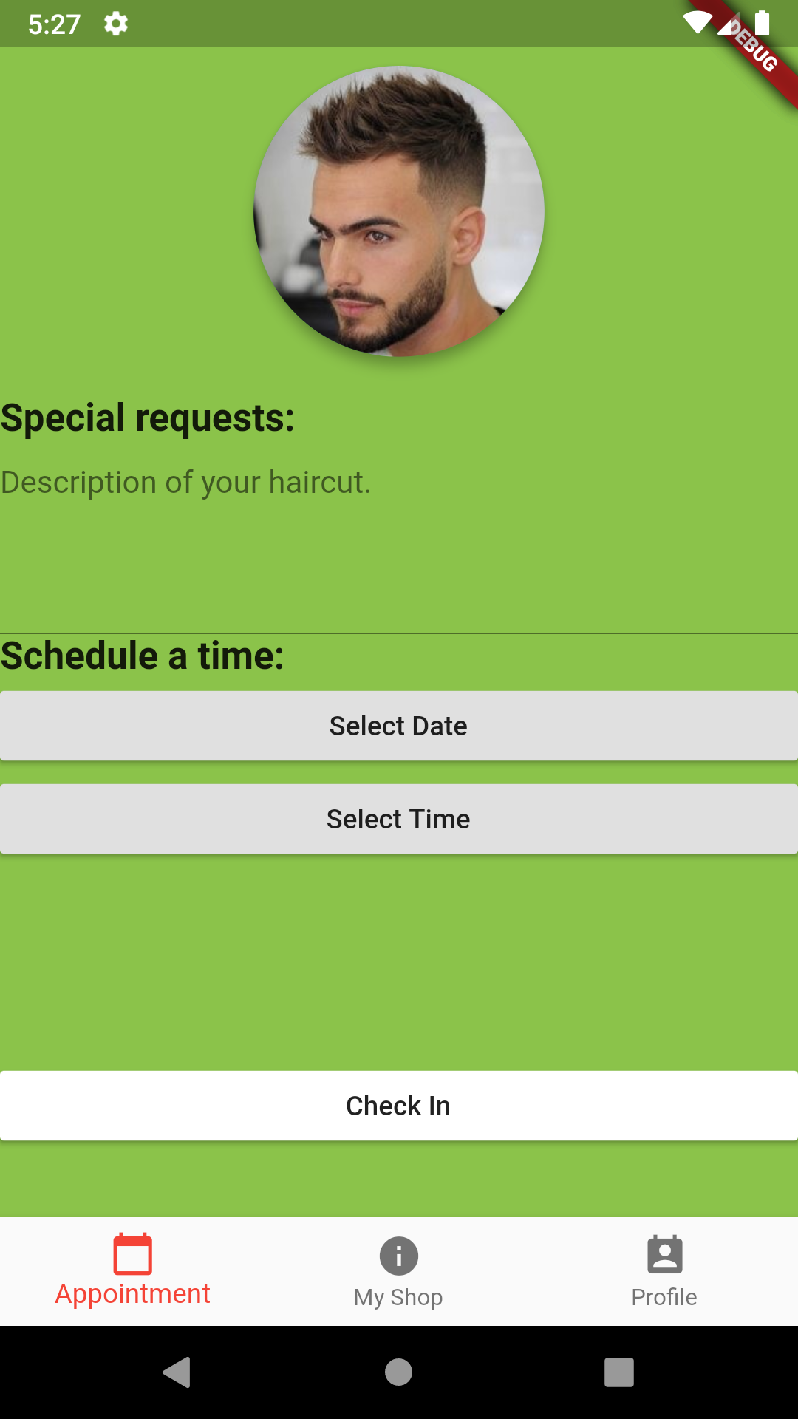

You add an image of the haircut you want by tapping on the camera button at the top of the screen and selecting a photo from your gallery. You then will need to crop the image into a square. When you click the check mark in the top right corner after cropping the image, you will be taken back to the form and your selected image will be displayed in the button the camera was in.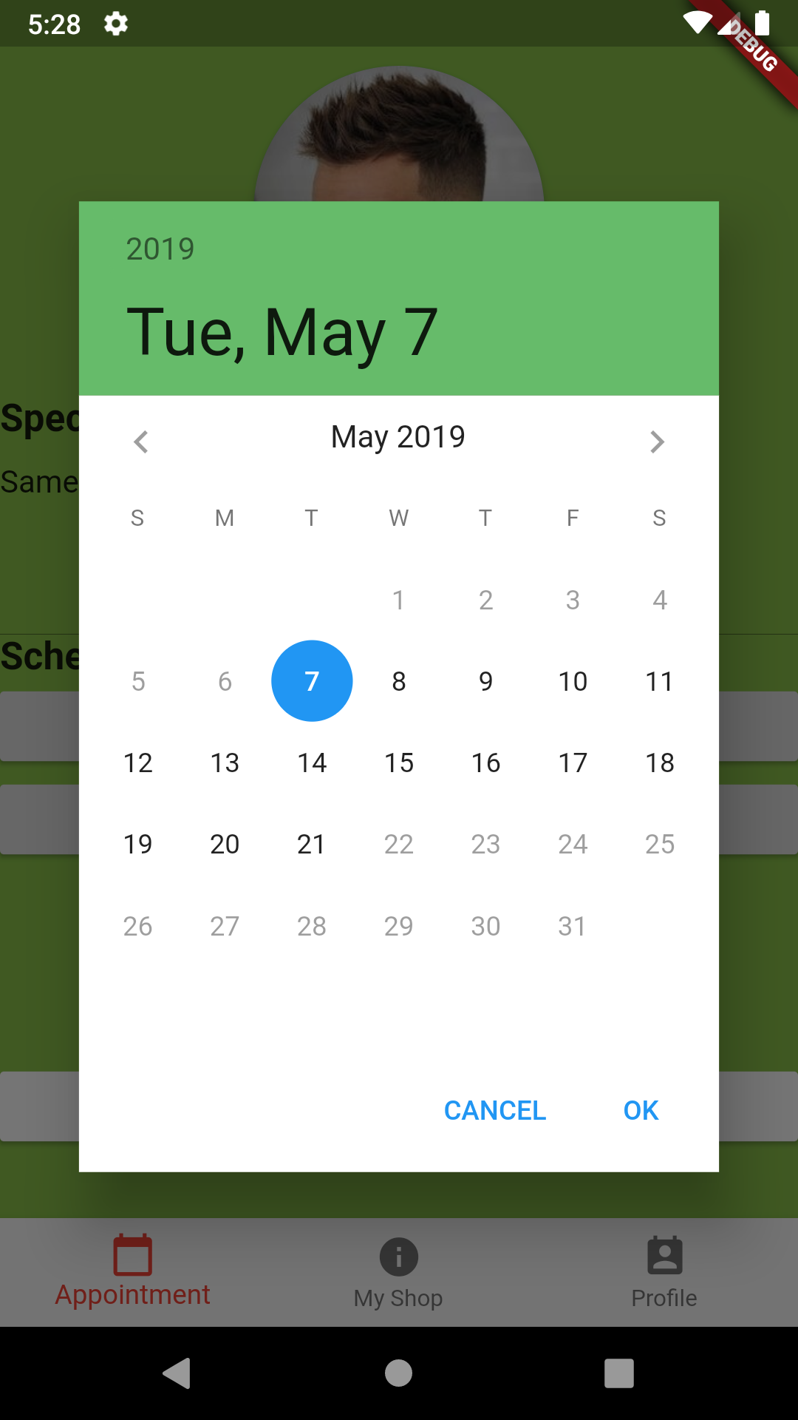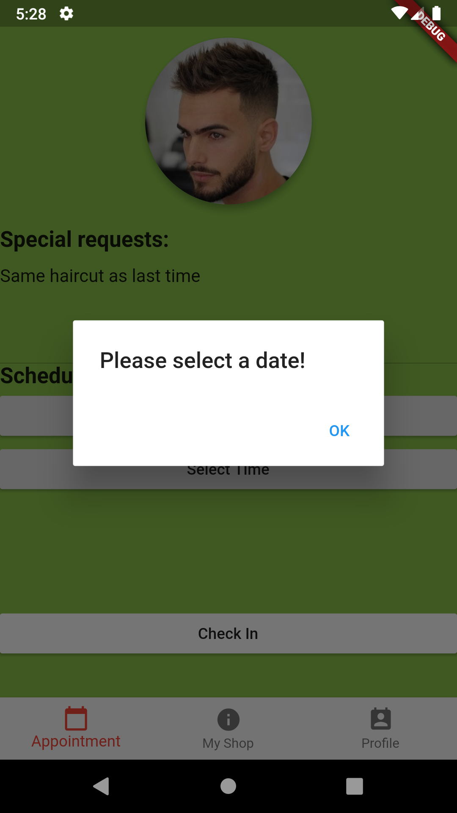

You need to enter a description of your desired haircut and select a date and time. When you tap on the select date and select time buttons, a dialog will pop up with a calendar and a clock for you to select your date and time.

If any of the information is missing and you try to submit the form then a dialog will prompt you to fix the errors.

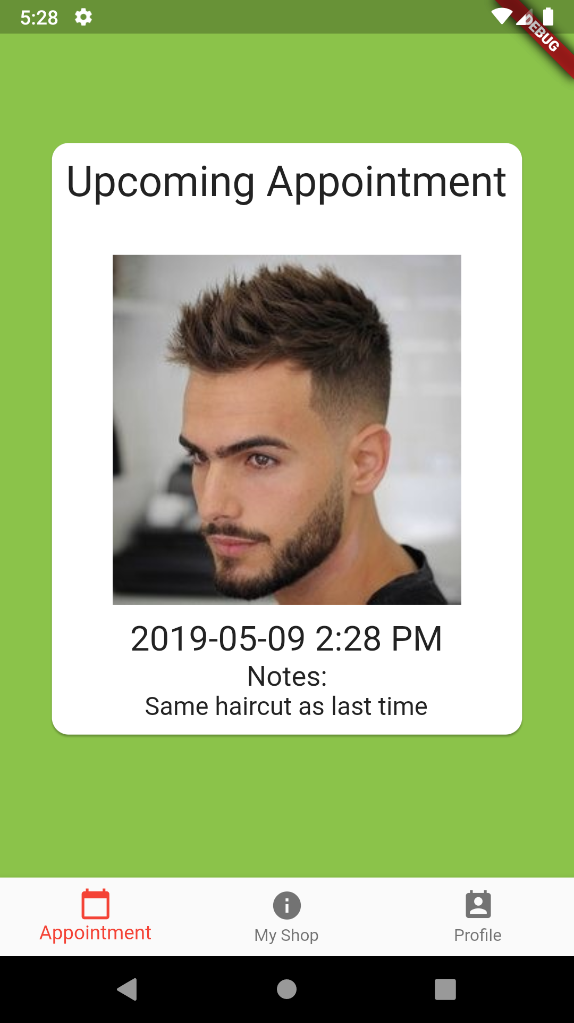

Once all of the information is correct, then you can click the check-in button and you will be shown a card with the appointment information on it.

**My Shop Page**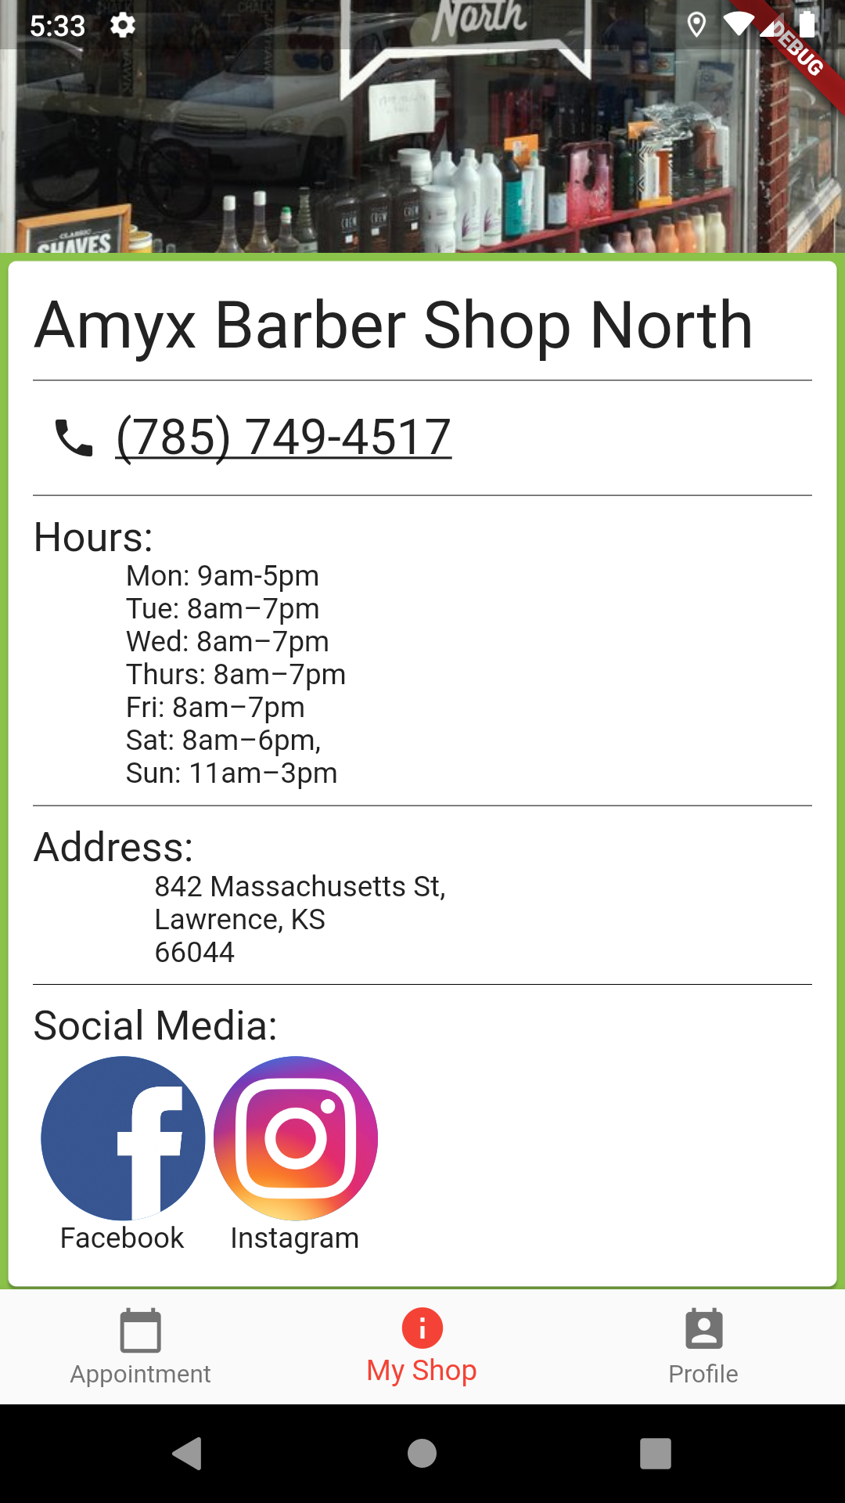

You can navigate to my shop page by clicking on the tab at the bottom labeled my shop. This page is to show the customer information about the barbershop. It includes the name of the shop, the phone number, hours of operation, address, and some links to the shop’s social media links.

When you click on the phone number, it will open the phone app on your device, so you can call the shop. When you click on the links to social media, it will open the corresponding social media link.

**Profile Page**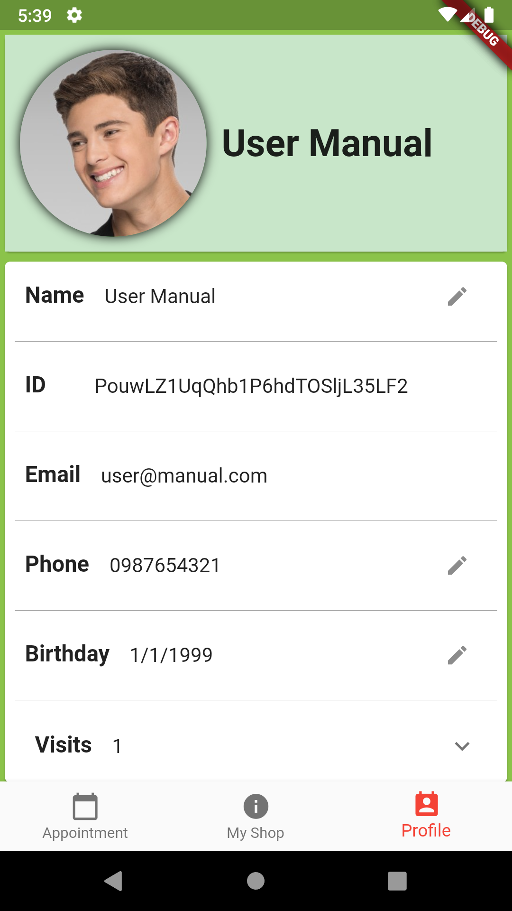

The profile page can be navigated to by tapping on the profile tab at the bottom of the screen. The profile page shows you information about your account, including your profile picture, name, userid, email, phone, birthday, and previous appointments made.

From this page, you are able to edit your account information. If a field has a pencil icon on the right hand side, then you can tap on the icon and it will open a dialog and allow you to change the information for that field.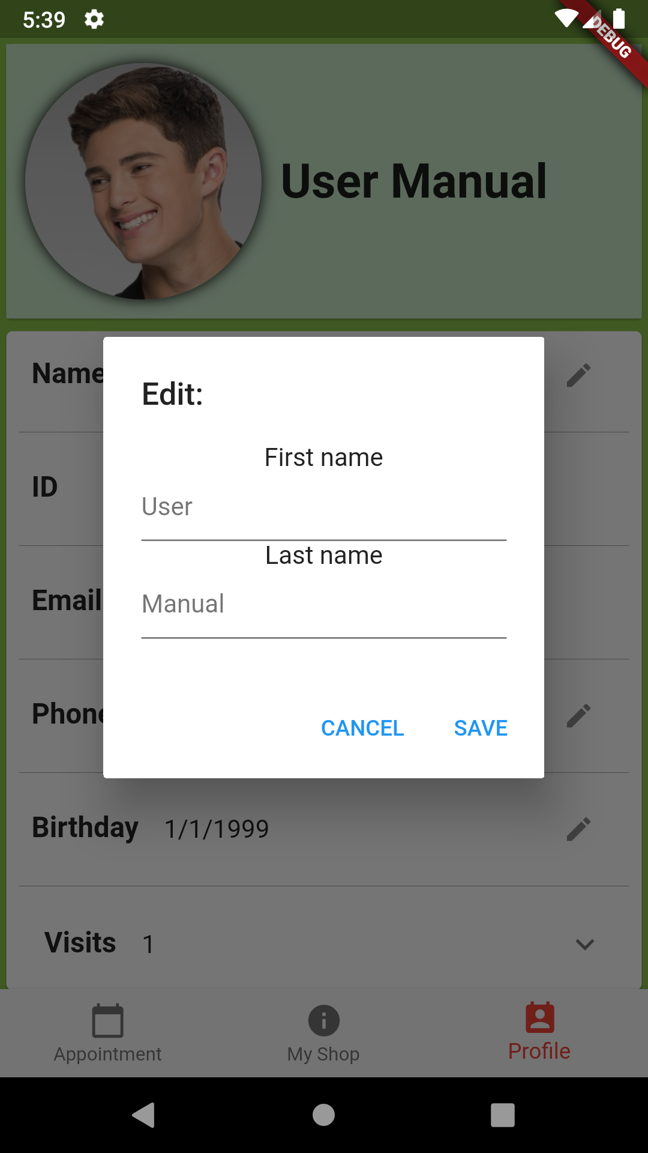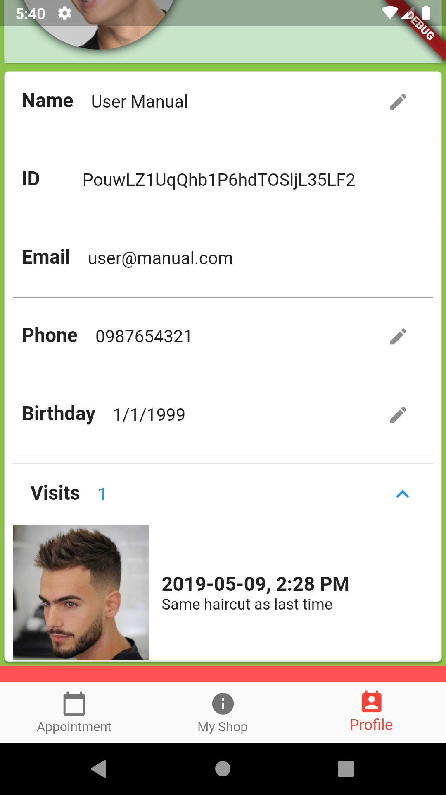

You can also view your past appointments from this page. To do this tap on the visits field and if you have any previous visits, then they will be listed here. 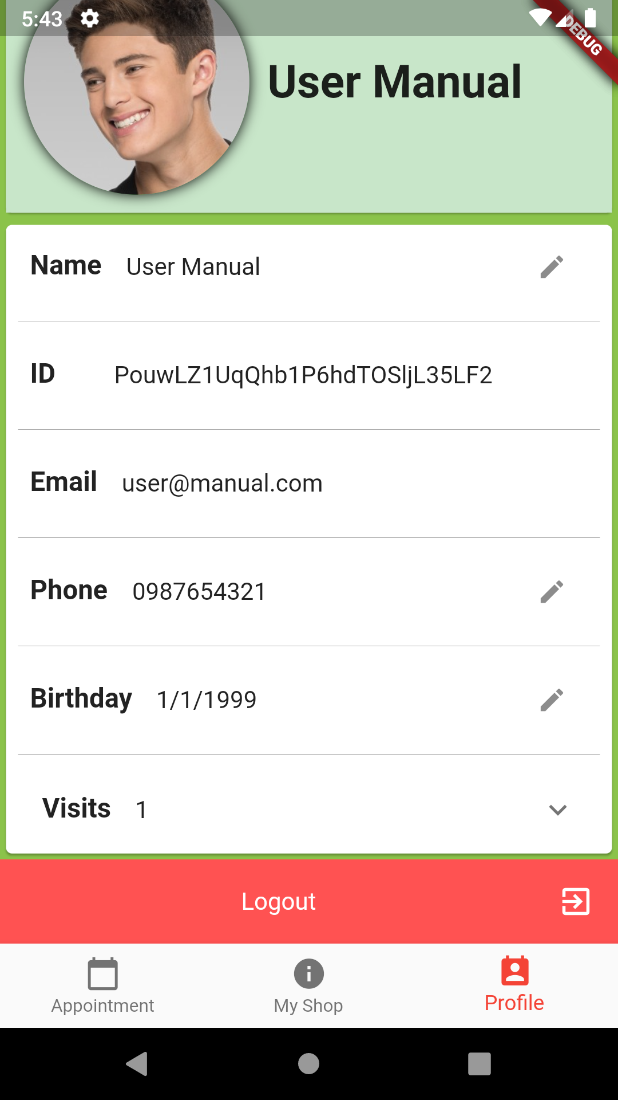

You can also log out of your account by clicking the red logout button at the bottom of your profile. This will take you back to the login and signup pages.